25200900131 – VADLAMUDI RISHI PRADYUMAN
PRACTICAL – 5
PROGRAM 1

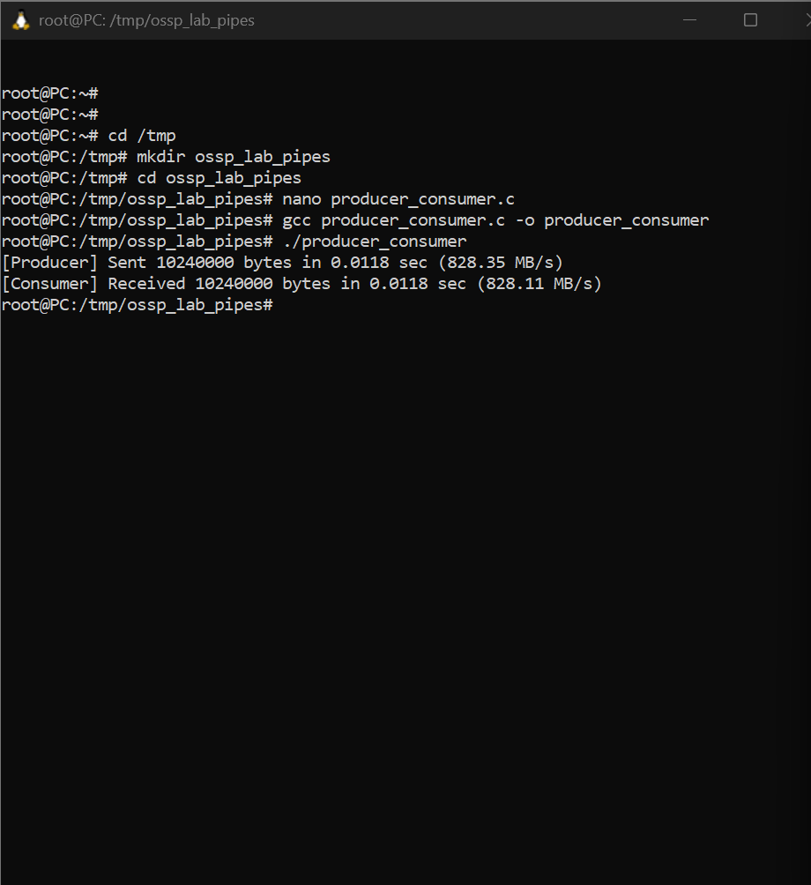
PROGRAM 2
